**Inter-Aspect Relation Modeling with Memory Networks in Aspect-Based Sentiment Analysis**

1 Introduction

We hypothesize that our architecture iteratively models the influence from the other aspects to generate accurate target aspect representation. In sentences containing multiple aspects, the main challenge an Aspect-Based-Sentiment-Analysis (ABSA) classifier faces is to correctly connect an aspect to the corresponding sentiment-bearing phrase (typically adjective). The aim of the ABSA classifier is to learn these connections between the aspects and their sentiment bearing phrases. The sentiment of an aspect in a sentence can influence the succeeding aspects due to the presence of conjunctions. Thus, aspects when arranged as a sequence, reveal high correlation and interplay of sentiments.

2 Related Works

3 Method

3.1 Problem Definition

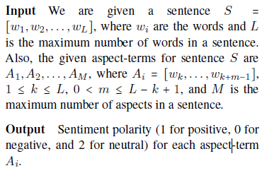

3.2 Model

The primary distinction between our model and the literature is the consideration of the neighboring aspects in a sentence with the target aspect.

3.2.1 Overview

**Input Representation** We replace the words in the input sentences and aspect-terms with pre-trained Glove word embeddings.

**Aspect-Aware Sentence Representation** Following Wang et al. (2016), all the words in a sentence are concatenated with the given aspect representation. These modified sequence of words are fed to a gated recurrent unit (GRU)2 for context propagation, followed by an attention layer to obtain the aspect-aware sentence representation; we

obtain for all the aspects in a sentence.

**Inter-Aspect Dependency Modeling** We employ memory network (Sukhbaatar et al., 2015) to model the dependency of the target aspect with the other aspects in the sentence. This is achieved through matching target-aspect-aware sentence representation with aspect-aware sentence representation of the other aspects. After a certain number of iterations of the memory network, we obtain a refined representation of the sentence that is relevant to the sentiment classification of the target aspect. Further, this representation is passed to a softmax layer for final classification.

3.2.2 Input Representation

The words (wi) in the sentences are represented with 300 (D) dimensional Glove word embeddings. Similarly, aspect terms are represented with word embeddings. Multi-worded aspect terms are averaged over the constituent words.

3.2.3 Aspect-Aware Sentence Representation

It would be fair to assume that not all the words in a sentence carry sentimental information of a particular aspect (e.g., stop words have no impact).

3.2.4 Inter-Aspect Dependency Modeling

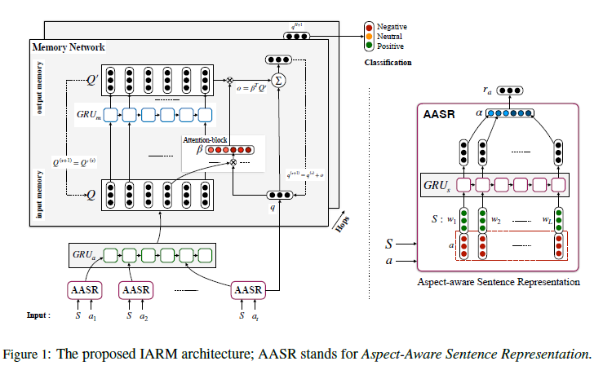

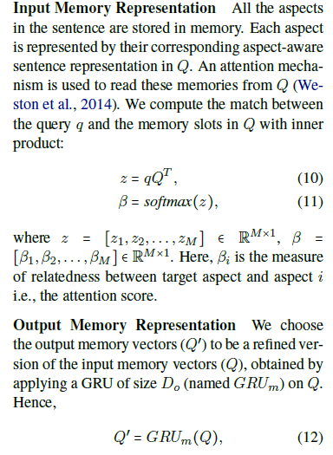

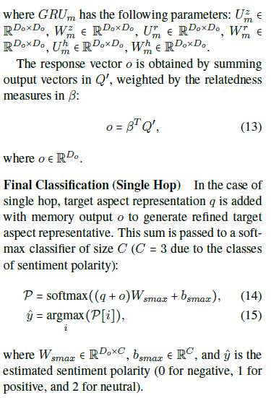

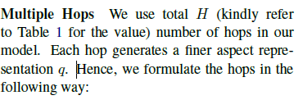

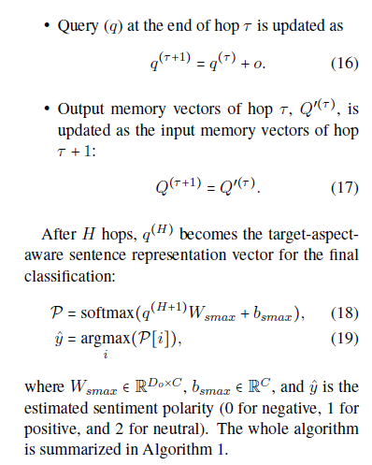

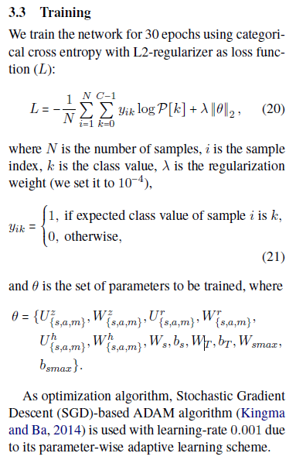

**Hyper-Parameters** We employed grid-search to obtain the best hyper-parameter values. Table 1 shows the best choice of these values.

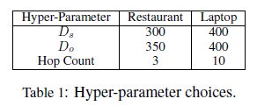

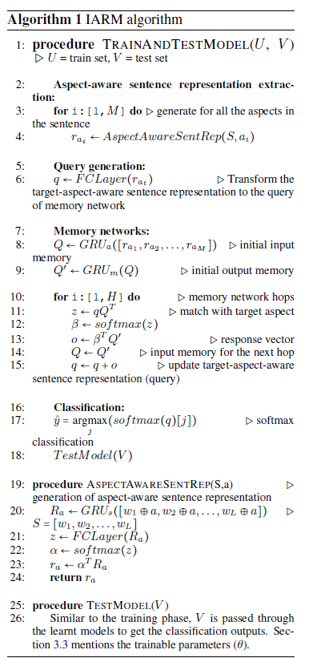

4 Experiments

4.1 Dataset Details

. 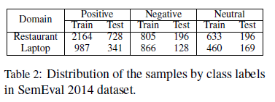

4.2 Baseline Methods

**LSTM**

**TD-LSTM**

**AE-LSTM**

**ATAE-LSTM**

**IAN**

4.3 Experimental Settings

**Overall Comparison** IARM is compared with the baseline methods for both of the domains.

**Single Aspect and Multi Aspect Scenarios**

**Cross-Domain Evaluation**

5 Results and Discussion

5.1 Case Study

5.2 Error Analysis

5.3 Hop-Performance Relation

6 Conclusion

In this paper, we presented a new framework, termed IARM, for aspect-based sentiment analysis. IARM leverages recurrent memory networks with multi-hop attention mechanism. We empirically illustrate that an aspect in a sentence is influenced by its neighboring aspects. We exploit this property to obtain state-of-the-art performance in aspect-based sentiment analysis in two distinct domains: restaurant and laptop. However, there remains plenty of room for improvement in the memory network, e.g., for generation of better aspect-aware representations